Introductory Topics

Introduction to Cable Attachment Guide
Thank you for your interest in utilizing Shelby Energy Cooperative poles to support your communication attachment in the State of Kentucky. As a rural electric cooperative, we know more than anyone the value of reliable high-speed internet access and the positive effect it has on our members and the rural communities we serve. We want to work collaboratively with all attachers to help expand your services across our service territory but our responsibility to the safety and reliability of the electric service we provide must come first and foremost. Cooperative has put together this guide as a convenient reference for third-party communication attachers and their partners to aid in their understanding of the requirements and expectations of working on Cooperative’s electric system.

Glossary of Basic Pole Attachment Terminology
For the purpose of this Guide, the following terms have the following meanings. This glossary is not intended to provide legal definitions for each term but to serve as a reference throughout the reading of the Guide.

Attached Pole: a Pole upon which two or more parties have facilities established.
Attacher: any party seeking to attach or having attached new or upgraded facilities to a Pole.
Attachment: any cable, wire, strand, circuit, service drop, permitted over-lashing, appurtenance, equipment, pedestal, or apparatus of any type belonging to one party attached to a Pole owned by a different party
Communication Space: lower usable portion of a Pole reserved for low voltage communications equipment.
Communication Worker Safety Zone: the space on a Pole below the Electric Supply Space, above the Communications Space. This space is defined by the National Electric Safety Code (NESC).
Cooperative: is the party owning the pole to which the other party is attached. For the purposes of this guide the Cooperative is Shelby Energy Cooperative.
High Volume Orders: requests which seek to attach to no more than three percent (3%) of Cooperative’s Poles in Kentucky or to no more than 3,000 Poles, whichever is less, and are not Lesser Volume Orders. Cooperative may treat multiple requests from a single applicant as one request if the requests are submitted within thirty (30) days of one another.
Lesser Volume Orders: requests which seek to attach to no more than zero and seventy-five hundredths percent (0.75%) of Cooperative’s poles in Kentucky or to no more than 500 Poles, whichever is less. Cooperative may treat multiple requests from a single applicant as one request if the requests are submitted within thirty (30) days of one another.
Make-ready: all work necessary or appropriate to make space for or otherwise accommodate new or changed Attachments
Power Make-ready: any Make-ready required of the electric utility necessary or appropriate to make space for or otherwise accommodate new or changed Attachments. Any Make-ready work requiring modification or replacement of equipment in the distribution system, including Pole change-outs.
Communications Make-ready: Make-ready in which existing Attachments in the Communications Space of a Pole could be rearranged without any reasonable expectation of a service outage or facility damage and does not require splicing of any existing attachment or relocation of an existing Wireless Facility. Simple Make-ready does not include replacement of a Pole.
Outside party: any third-party person or entity attached to the Pole as it relates to a specific interaction between a Pole-owner and an attacher
Overlashing: placing an additional wire or cable communications facility onto an existing Attachment or messenger already secure to the Pole in order to accommodate additional wire or cable communications facility capacity.
Permit: authorization from a Pole Owner to an Attacher to attach an Attachment to a Pole
Pole: any Pole owned or controlled by the Cooperative, excluding any Pole that is used primarily to support outdoor lighting or transmission-level voltages (greater than or equal to 69 kV)
Service Drop: a wire or line used to connect services to a single customer, building, or location by means of any attachment to a Pole. A Service Drop shall run directly from a Pole to a specific customer, without the use of any other Poles.
Supply Space:
Communications Supply Space: Authorized communications space of one foot per attachment below the Communication Worker Safety Zone
Power Supply Space: the upper most space above the Communications Worker Safety Zone containing or reserved for electric distribution equipment.
Transfer: the removal of attachments from one Pole and the placement of them or substantially identical attachments upon another Pole.
Wireless Facilities: telecommunications or data transmission devices in which electromagnetic waves (rather than some form of wire or fiber) carry the signal over part or all of the communication path. Wireless facilities are not addressed by this guide.

Safety Expectations of Working Near Overhead Electrical Distribution Systems
Electric distribution lines are inherently dangerous and proper care should be taken when working on any part of the distribution system. Employees or contractors working on behalf of any communications attacher shall follow all applicable safety standards including OSHA (Occupational Health and Safety Administration), NESC, NEC (National Electric Code), etc.

In general, communications contractors should only be working below the Communication Worker Safety Zone. Any person working above the communications space must be qualified to be in the power space. Supervisors must be qualified and competent to oversee work on utility poles. Only approved contractors identified on Cooperative website as appropriately qualified and approved by Cooperative to provide self-help Make-ready services may work above the Communication Space in accordance with the terms and conditions set forth in Cooperative’s, tariff and policies and procedures, and in accordance with the Kentucky Public Service Commission’s Pole Attachment Regulation.

Use of this Guide / Governing Authority
As stated, this guide is intended to serve as a convenient reference for third-party communication attachers and their partners to aid in their understanding of the requirements and expectations of working on Cooperative’s electric system. To be clear, this guide does not replace or supersede applicable law (including KRS Chapter 278 and 807 KAR 5:015), the terms set forth in the Cooperative’s tariff on file with the Kentucky Public Service Commission, or the terms of an existing agreement between the Cooperative and an attacher (if any) (collectively, “Other Applicable Authority”). In the event of a conflict between this guide and any Other Applicable Authority, the terms of the Other Applicable Authority shall prevail.

Structure of the Distribution Pole and Working Zones on the Pole
Figure 1 – Distribution Pole with working zones identified
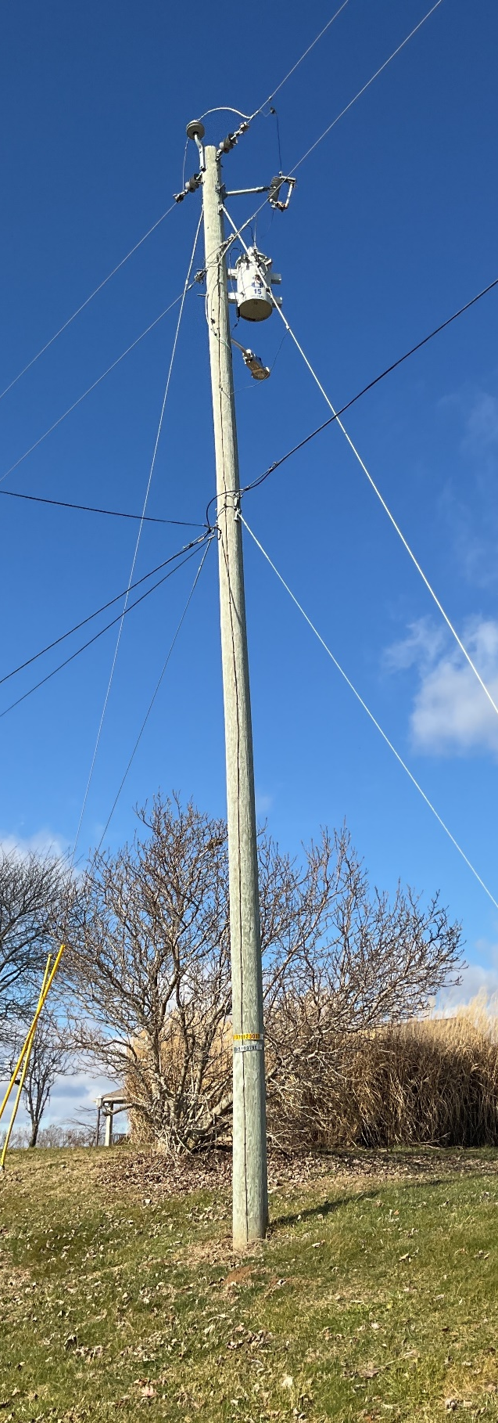

Communications Space – Lower portion of pole dedicated to communications attachment. Attachments in this zone should maintain 12” minimum of separation between other communication attachments.
Power Supply Space – reserved for electric distribution use. Communications attachments and unqualified workers should not be in this working zone on the pole.
Communication Worker Safety Zone – buffer zone measured between lowest power equipment and top communications attachment. Defined by NESC
Ground clearance- distance defined by NESC to provided necessary clearance for mainline attachments at the pole and midspan. Attachers may utilize this zone below its specifically authorized space for terminals, risers or other reasonable vertical Attachments on the pole if the existing use of the Pole is authorized, such use does not interfere with any Outside Party’s operations, and such use complies with the terms of this Schedule. (See Design & Engineering, and Make-ready Work & Construction for detail information about specific clearance distances)

Electrical Distribution System Planning: Future Use of Cooperative Poles
Cooperative retains the right to reserve space on the poles for future use of the electric system. Communication attachments should be placed according to plans approved by the Cooperative to ensure that reserved space is not encroached upon. Attachments that are not affixed according to approved plans shall be corrected at the cost of the attacher or may be corrected by the Cooperative and billed to the attacher.

Application for Permit to Attach

Process and Procedures

All new attachments must be approved by the Cooperative before being placed on the Pole. Cooperatives have established the Permit to Attach procedure to guide this process. Some parts of this process are established by the Kentucky Public Service Commission while other parts were included to improve the efficiency of approving the permit requests. It is important to note that attachers should always reference the agreement or tariff they are operating under when preparing to submit a new request to attach.

  - Figure 2 – Sample Permit Timeline* *This is a sample timeline provided for illustrative purposes only. The actual timeline may vary in accordance with the terms of the Cooperative’s tariff, the Kentucky Public Service Commission’s Pole Attachment Regulation, or for reasons of safety, service interruptions, or good cause shown.

Accuracy is very important in the first step in the process -- the preparation of the permit application package. Incomplete or inaccurate applications will be rejected.

Third Party Attachers must allot ample time to perform the field engineering necessary to safely, accurately, and efficiently prepare a permit application package, and to properly complete the remaining steps in the permit application process. Sample documents will be provided to the Attacher upon request to ensure its submission meets the Cooperative’s expectations and expedites the permitting process as much as possible.

The Cooperative may deviate from the timelines in this section for good and sufficient cause that renders it commercially infeasible to complete the relevant task within the specified time limits. If the Cooperative deviates from the timeline, it will immediately notify the affected Attachers in writing or via the electronic means designated by Cooperative. In the case of Make-ready work, the Cooperative’s notification will identify the affected Poles and explain the reason for the deviation and provide a new completion date. The Cooperative will deviate from the timelines specified in this section for a period no longer than necessary to complete Make-ready on the affected Poles and will resume Make-ready without discrimination when it returns to routine operations.

Steps for Permit to Attach

- Permit Submittal
All Pole permit applications are to be submitted to Cooperative through the means designated by the Cooperative. Permit submittal must also include a completed pole attachment form with the applicable contact information. When Attacher submits its permit application, it may be required to submit a unit-based survey fee provided in APPENDIX E – FEES AND CHARGES, based on the number of Poles included in the permit application. The Attacher shall pay the permitting fee to the Cooperative or the Cooperative’s Permit Process Contractor as provided in Article IV. The actual cost will be trued up as described in step 4 or step 6 below.

- Review for Completeness
Cooperative will review Attacher’s Pole permit application for completeness before reviewing the application on its merits. Cooperative will notify the Attacher within ten (10) Business Days after receipt of the Pole permit application if the application is incomplete. Cooperative shall have one additional business day for every 500 pole increment over 500 Poles.

Any incomplete applications will be rejected and returned to the Attacher with an explanation of the reason it is being rejected.

- Survey / Review on Merits
Attacher may choose to use an approved contractor listed on the Cooperative’s website to prepare a survey to submit with an application for 500 poles or fewer. Attachers submitting surveys with requests should ensure that the survey was completed no more than 30 days prior to submission by an approved contractor.

Cooperative must conduct a survey for applications containing more than 500 poles. Cooperative shall complete an inspection of Poles for which access has been requested within 45 Days of receipt of a complete application involving Lesser Volume Orders. With respect to High Volume Orders, Cooperative will complete the survey and review on the merits and either grant or deny the applicant access within up to one hundred twenty (120) days of receipt of a complete Application to be calculated as follows: Cooperative shall have an additional fifteen (15) days to complete the survey and review on the merits, grant or deny access and identify any Make-ready for each 500-Pole increment over the first five hundred (500) Poles in an Application up to the lesser of three thousand (3000) Poles or three percent (3%) of the Cooperative’s Poles in Kentucky.

Based on the results of the inspection and other relevant information, the Cooperative will respond to the Attacher by granting or denying access. Any denial of access will include specific information supporting the denial of access.

Note: Inspection costs to review the Attacher’s application are the responsibility of the requesting Attacher even if the requesting Attacher elects not to move forward with the attachments. After completing review on merits, if there is no Make-ready required, the Cooperative will provide the Attacher a detailed, itemized invoice for the inspection and review work on the permit. Both parties will coordinate on truing up the costs of the permit to what the Attacher has paid up to this point. The Attacher will be refunded the difference if the Attacher has overpaid and will pay the difference to Cooperative if Attacher has underpaid.

- Make-ready estimate
Within 14 Days of providing a response to a permit application granting access to a Pole, the Cooperative will send the Attacher a written estimate of charges to perform necessary Make-ready work (“Make-ready Work Estimate”)

If, after receipt of the Make-ready Work Estimate, the Attacher wishes to proceed with the Attachment, then Attacher shall provide Cooperative written confirmation that Attacher accepts the estimate of charges and will pay the cost of the Make-ready Work as estimated by the Cooperative, together with advance payment of the entire estimated cost of the Mark-Ready Work.

Cooperative will schedule Make-ready construction to begin when it receives full payment from Attacher of the entire Make-ready Work Estimate.

Cooperative's Make-ready Work Estimates will be valid for 14 Days after presentation. Thereafter, all Make-ready Work Estimates will be automatically withdrawn and Attacher must request a new estimate.

- Make-ready Construction
Within 7 Days of receipt of Make-ready payment, Cooperative will begin notifying all known entities with existing attachments that could be affected by the Make-ready work.

The Cooperative will complete Make-ready work in the supply space in 90 Days for Lesser Volume Orders and up to 165 Days for High Volume Orders. The Cooperative has sole discretion to extend this Make-ready timeline by 15 Days to complete the Make-ready work.

After completing Make-ready construction, the Cooperative will provide the Attacher an invoice for the inspection and Make-ready work on the permit. Both parties will coordinate on truing up the actual costs of the permit to what the Attacher has paid up to this point. The Attacher will be refunded the difference if the Attacher has overpaid and will pay the difference to Cooperative if Attacher has underpaid.

- Post Construction Inspection
Upon receipt of payment for the final invoice for the inspection and Make-ready work, Cooperative will issue the Attacher authorization in the form of a Permit to use the relevant Poles and to make Attachments in accordance with the terms of this Manual and the Pole Attachment License Agreement. The Attacher will have 180 Days from the date Cooperative issues a Permit to complete installation of the Attachment. If the Attachment has not been completed within the 180-Day period, the Permit will automatically terminate without further notice. Attacher shall notify Cooperative within 15 Business Days following completion of all Attachments within an application to attach using the means designated in the Pole attachment tariff.

Upon receipt of said notice, the Cooperative will have at least 90 Business Days to inspect the Attachment. Cooperative will have fourteen (14) Days after completion of its inspection to notify the Attacher of any damage or code violations caused by the Attachment. If Cooperative discovers damage or code violations caused by the Attachment, then Cooperative will inform Attacher and provide adequate documentation of the damage or code violations.

Cooperative may complete any necessary remedial work and bill Attacher for the reasonable costs related to fixing the damage or code violations, or Cooperative may require Attacher to fix the damage or code violations at Attacher’s expense within fourteen (14) Days following notice from Cooperative. Attacher will be responsible for reasonable engineering and inspection costs incurred by Cooperative in connection with Post-Construction Inspection and any remedial work.
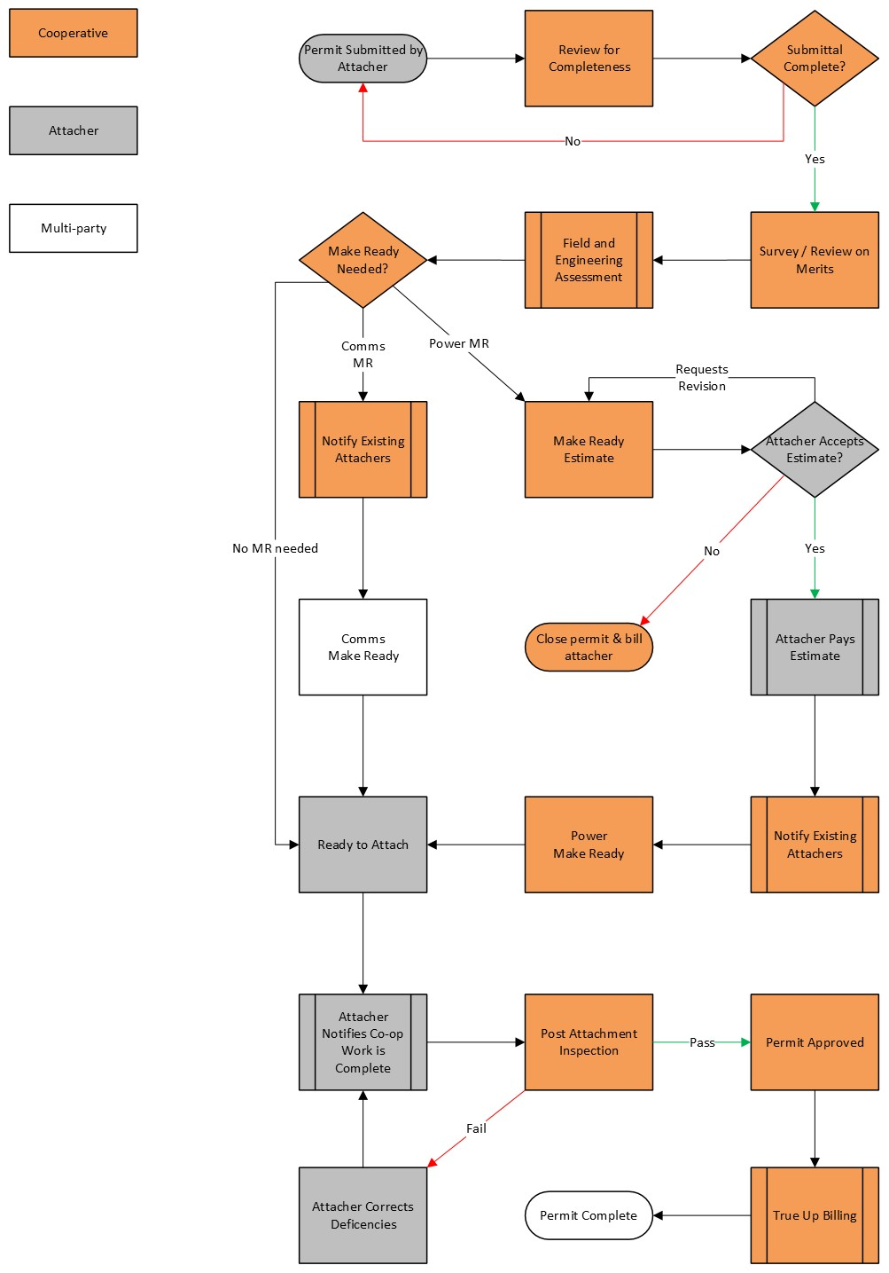
Figure 3 - Permitting Process Flowchart

Software

Alden One
Cooperative uses AldenOne asset management software for managing attacher permitting. All permits should be submitted through the web portal. Please refer questions regarding AldenOne to the help page at https://help.aldenapps.com/htmlapp/help.html or your permitting contact directly.

Cooperative does not use a software solution to receive and manage attacher permitting. Please submit completed Appendix A and supporting documentation to JointUse@shelbyenergy.com to initiate a permit request.

Permit Size Limit
Lesser Volume Orders: requests which seek to attach to no more than zero and seventy-five hundredths percent (0.75%) of Cooperative’s poles in Kentucky or to no more than 500 Poles, whichever is less. Cooperative may treat multiple requests from a single applicant as one request if the requests are submitted within thirty (30) days of one another.
High Volume Orders: requests which seek to attach to no more than three percent (3%) of Cooperative’s Poles in Kentucky or to no more than 3,000 Poles, whichever is less, and are not Lesser Volume Orders. Cooperative may treat multiple requests from a single applicant as one request if the requests are submitted within thirty (30) days of one another.

All orders submitted within thirty (30) days of one another may be counted as one request for timeline purposes. Orders above the lesser of 3,000 Poles or 3 percent of the owner’s Poles in the state shall be completed under a special contract between the Cooperative and Attacher. Please contact the Cooperative directly while planning the project to begin discussions about special contracts.

Overlashing
- Prior Approval
The Cooperative will not require prior approval for:
- An existing Attacher that overlashes its existing wires on a Pole; or
- For third party overlashing of an existing attachment that is conducted with the permission of an existing Attacher.

- Preexisting Violations
The Cooperative will not prevent an Attacher from overlashing because another existing Attacher has not fixed a preexisting violation. The Cooperative will not require an existing Attacher that overlashes its existing wires on a Pole to fix preexisting violations caused by another existing Attacher.

- Advance Notice
The Cooperative requires 30 Days' advance written notice of planned overlashing through the designated electronic means as detailed in Section VII, including documents similar to the sample documents provided to the Attacher for the permitting process.

If after receiving such advance written notice, the Cooperative determines that an overlash would create a capacity, safety, reliability, or engineering issue, it will provide specific documentation of the issue to the Attacher seeking to overlash within the 15-Day advance notice period.

The Attacher seeking to overlash must address any identified issues before continuing with the overlash. If any Make-ready Work and/or third-party rearrangement is required for the proposed overlash, the Attacher may not proceed with the overlash until any necessary Make-ready Work and/or third-party rearrangement is completed. In the event a proposed overlash requires Make-ready Work, Cooperative will exercise reasonable diligence to complete any necessary Make-ready Work within sixty (60) Days.

The Cooperative will not charge a fee to the Attacher seeking to overlash for the Cooperative's review of the proposed overlash. If Make-ready work is required, Attacher will be responsible for all Make-ready costs.

- Overlasher’s Responsibility
Any Attacher that engages in overlashing is responsible for its own equipment and will ensure that it complies with reasonable safety, reliability, and engineering practices. If damage to a Pole or other existing attachment results from overlashing or if overlashing work causes safety or engineering standard violations, then the overlashing party is responsible at its expense for any necessary repairs. Attacher must remove and dead or un-used equipment (cabling or facilities) before overlashing new attachments to the bundle.

- Post-Overlash Review
Attacher must notify the Cooperative through the designated electronic means detailed in Section VII within 15 Days of completion of the overlash on a particular Pole. The notice will provide the Cooperative with at least 90 Days to inspect the overlash.

The Cooperative has 14 Days after completion of its inspection to notify the overlashing party of any damage or code violations to its equipment caused by the overlash.

If the Cooperative discovers damage or code violations caused by the overlash on equipment belonging to the Cooperative, then the Cooperative will inform the overlashing party and provide adequate documentation of the damage or code violations.

The Cooperative may either complete any necessary remedial work and bill the overlashing party for the reasonable costs related to fixing the damage or code violations or require the overlashing party to fix the damage or code violations at its expense within 14 Days following notice from the Cooperative.

Any Overlashing for which the Attacher fails to follow the procedures prescribed in this Manual shall be deemed to be an Unauthorized Attachment.

Except as otherwise specified in this Manual, Attacher’s Overlashing shall be subject to all other covenants, representations, and warranties in the Pole Attachment License Agreement applicable to Attachments.

Service Drops
Service Drops are not required to be permitted through the permit application process described in this Communications Attachment Guide. To be clear, a Service Drop only goes from a Pole to a point of service – it does not go from Pole to Pole across multiple spans, even if the spans at issue ultimately terminate at a point of service. New service lines are required to adhere to the specifications listed in this guide. Service lines must be permitted for attachment to Poles where the Attacher does not have already existing attachments.

Easements and Property Rights
The Cooperative is not required to secure any right-of-way, easement, license, franchise, or permit required for the construction or maintenance of attachments. While an Attacher may be permitted to make attachments and access Poles under the compatible use standard, Attachers are responsible for ensuring rights of access and addressing issues with property owners regarding their access to Poles. Additionally, each Attacher and their contractors must always access existing rights of way with care and respect for the cooperative’s member and member’s property.

At a minimum, Attachers working on Cooperative members’ property should undertake a reasonable effort to minimize conflict with property owners. Attachers and their contractors should:

- Identify themselves to the property owner before accessing the property;
- Prevent damage resulting from equipment used or other activity on the property; and
- Address any damage or access issues directly with the property owner.

Design and Engineering
This section includes baselines clearances and basic reference drawings. Please refer to Appendix B – Specs at the end of this guide for additional specifications. The current edition of the NESC at the time of this publication is 2023.

NESC Clearances

Figure 4 – NESC minimum clearance table

Standard Electric Cooperative Construction – Pictorial Guide

Common Violation Examples

Clearance to Power

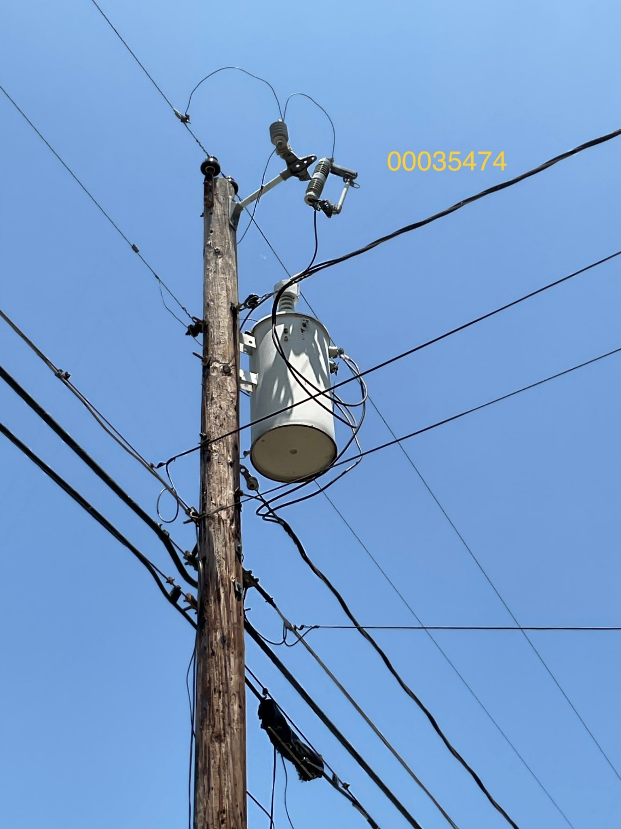
Figure 5.1: Communications attachments are too close to the lowest power on the pole (service/bottom of electric transformer)

Figure 5.2 – Communications attachments are above the top of the electric service riser in the power space.
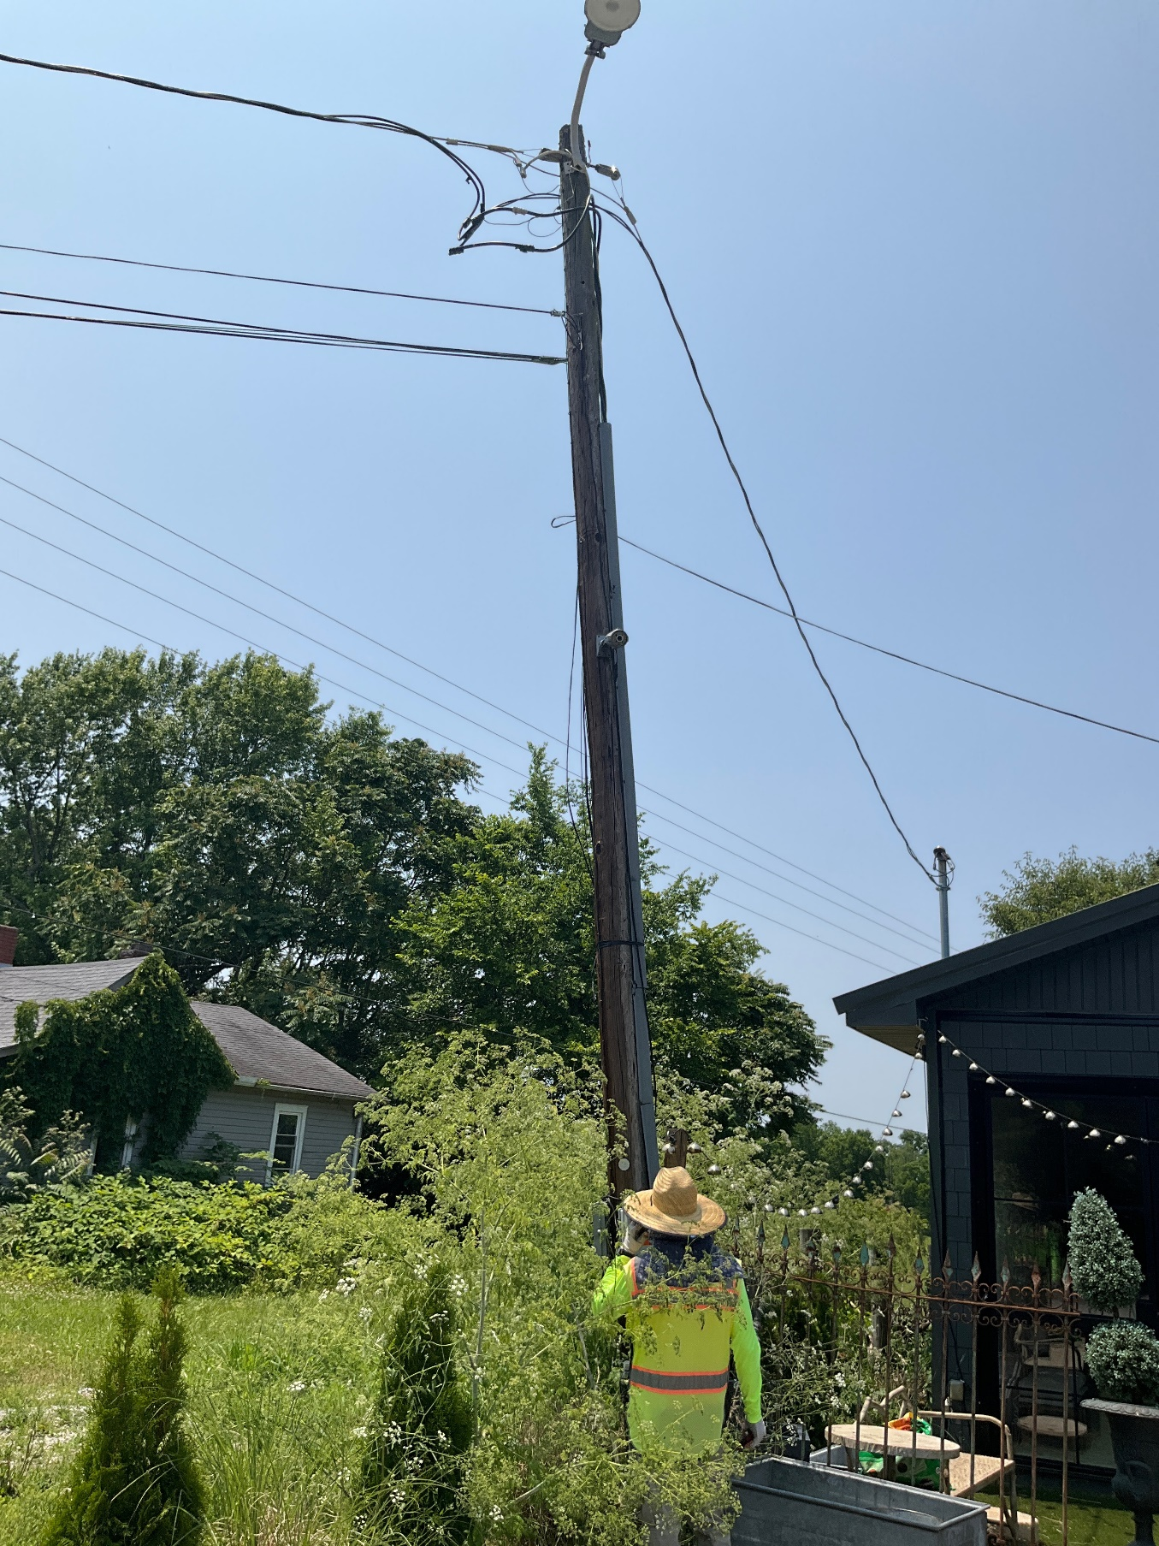
Low Height at Midspan
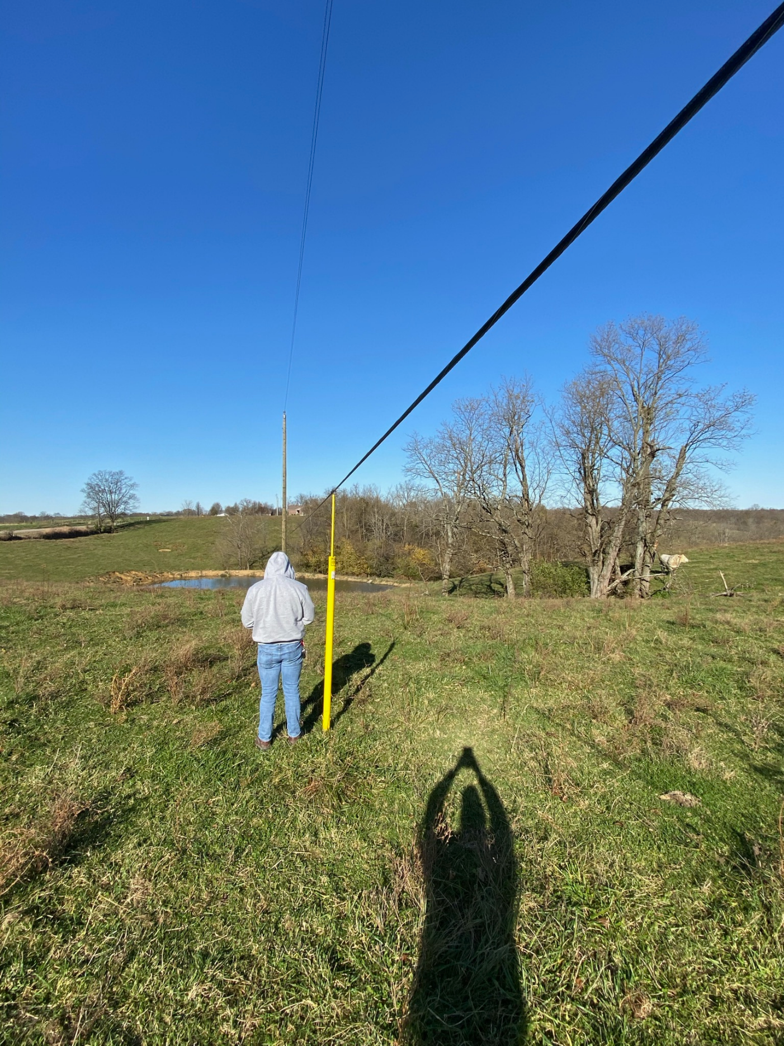
Figure 6 – Communications attachment appears to not be pulled to proper tension causing low midspan height.

Unbalanced Line Tension
Figure 7 – Unguyed angle attachment causing pole to lean in direction of unbalanced load. This can be dangerous for communications workers, electric linemen, and the general public.
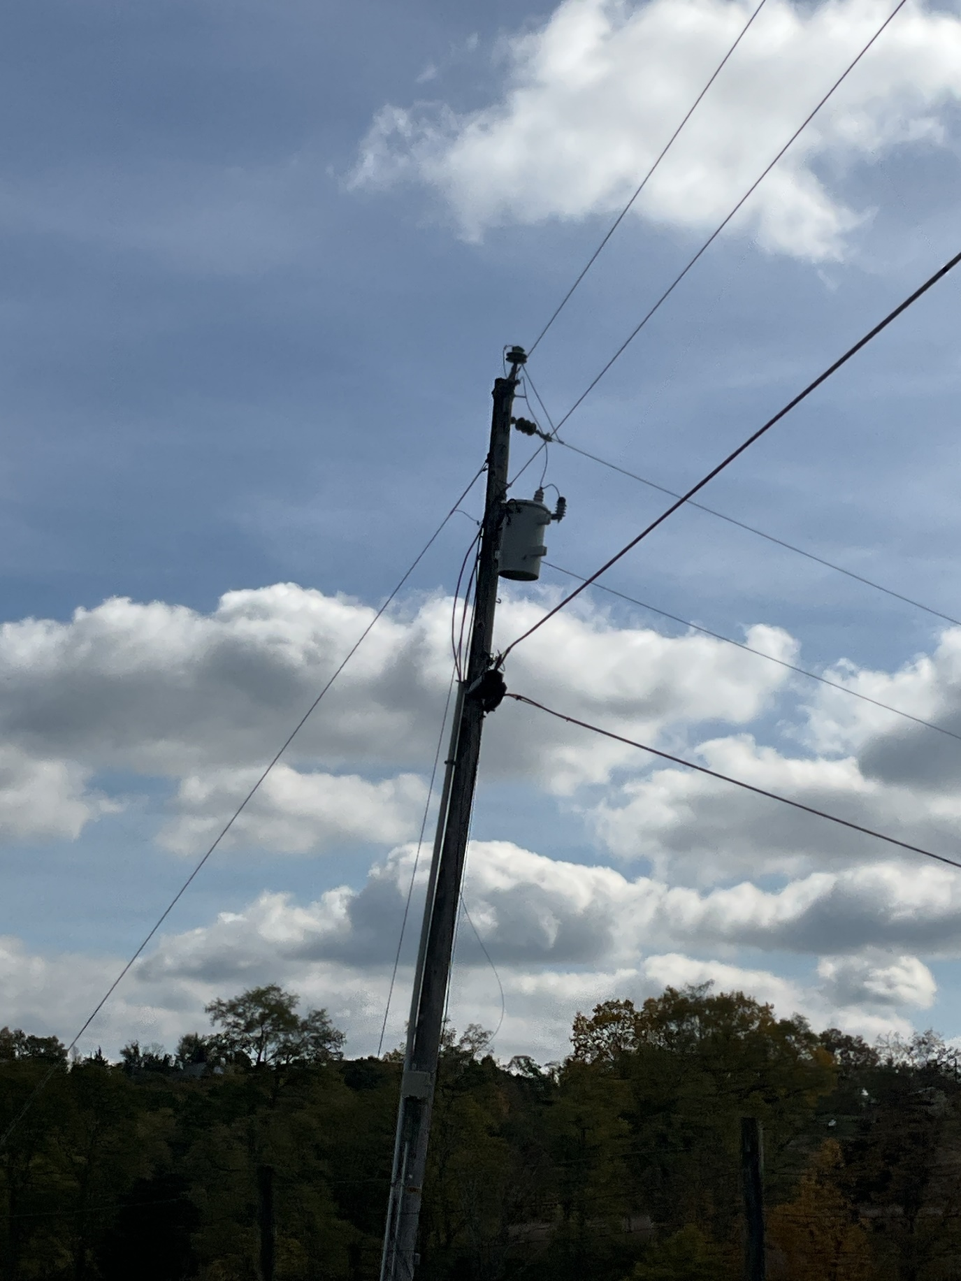
Improperly Placed Anchors
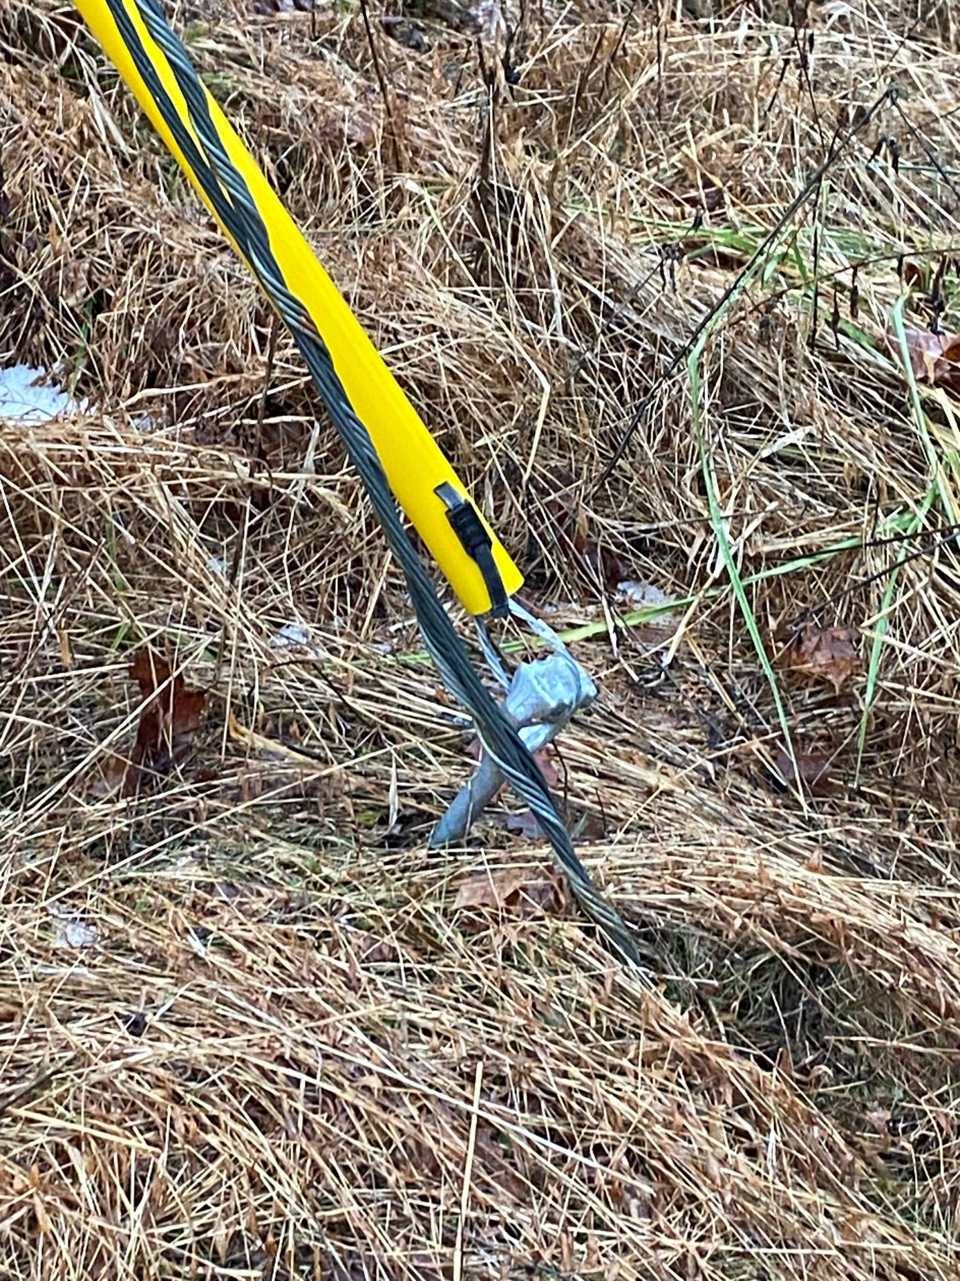
Figure 8 – Anchor is not installed in line with down guy. This allows for the potential of the anchor to be loosened back and forth over time preventing the anchor from properly backing the unbalanced load

Summary of RUS guides on Anchors
Reference RUS Bulletins 1724E-153 & 1728F-804. Guys and anchors are to be installed at telecommunication line deadends, line angles, and at points of unbalanced tensions. As much as practicable, anchors and rods shall be installed in line with, and in the opposite direction of, the resultant strain of the conductors. Anchor assemblies shall be installed so that approximately 6 inches of the rod remains out of the ground. In cultivated fields or other locations as deemed necessary, the projection of the anchor rod above earth may be increased to a maximum of 12 inches to prevent burial of the rod eye. The backfill of all anchor holes must be thoroughly tamped the full depth. After a cone anchor has been set in place, the hole shall be backfilled with coarse crushed rock for 2 feet above the anchor and tamped during the filling. The remainder of the hole shall be backfilled and tamped with dirt. Communications guys shall be placed at least 5 feet away from the nearest power anchor. Anchors and down guys must be installed simultaneously with the construction of the tensioned cable.

Bonding and Grounding
Reference RUS Bulletin 1751F-805. Protective measures shall be taken when installing telecommunication facilities in bonding and grounding. Bonding and grounding are basic principles that should be employed to prevent harmful potentials at telecommunications drops/customer locations. It is necessary to do so to avoid electric shock to users and the general public, and to also prevent any damage to customers’ property or telecommunication equipment itself. A properly installed grounding system functions by equalizing electrical potentials to create a low resistance path to ground directing any damaging currents away from persons and equipment.

Key Terms Defined:
- Bonding: The permanent joining of metallic parts to form an electrically conductive path to ensure electrical continuity and capacity to safely conduct any current likely to be imposed.
- Bonding Conductor: A conductor used to interconnect the telecommunications bonding infrastructure to the service equipment (power) ground.
- Effectively Grounded: An intentional connection to earth through a ground connection of sufficiently low impedance. It must have sufficient current-carrying capacity to be able to prevent the buildup of voltages that could potentially result in unnecessary hazard to connected equipment or persons.
- Ground: An intentional or accidental conducting connection between an electrical circuit or equipment and earth or other conducting body.
- Ground Electrode Conductor: A conductor used to connect the grounding electrode to:
  - The equipment grounding conductor
  - The grounded conductor of the circuit at the service equipment
  - The source of a separate system

Copper is the most often used material for bonding and grounding conductors. NEC Article 800-40 (a) (2) states that the grounding conductor shall be copper or other corrosion resistant conductive material, stranded or solid. To effectively ground telecommunication lines the use of compression connectors linking the communication messenger to the Pole ground is recommended. NESC states that if the messenger wire is an adequate system grounding conductor per Rules 093C1, 093C2, and 093C5, then a minimum of four connections in each mile are required. If the messenger wire is NOT an adequate system grounding conductor, at least eight connections are required in each mile exclusive of service grounds.

Pole Loading Analysis
Pole Loading Analysis is an essential prerequisite to obtaining an attacher permit. It is of utmost importance to provide accurate in-depth analysis of utility structures that adhere to all regulatory requirements set forth by governing entities. Pole Loading Analysis is to be submitted during the permitting process to determine the impact of additional attachment, or design Pole replacements. If the Attacher cannot perform the necessary analysis, they may elect to have the Cooperative do the work at the Attacher’s expense.

Make-ready Work & Construction

Ground Clearances
Ground clearance is the minimum distance wireline attachments must maintain above the ground to protect persons from hazards arising from the installation on utility Poles. Ground Clearances should be measured at the lowest point of sag within a span to the surface directly below the line.

Minimum Ground Clearances for communication lines as per 2017 NESC Tables 232-1 & 242-1
- Railroads: 23.5ft (Railway companies often require more)
  - Note: All CSX and Norfolk Southern railways require 27ft clearance for communications attachments.
- Roads subject to truck traffic: 15.5ft
  - Note: KYTC requires 18ft clearance for state and federal highways. Interstates (fully controlled access) require 24ft clearance.
- Oversized Vehicles greater than 14 feet in height:
  - known height of oversized vehicle + 1.5ft
- Water Surfaces:
  - 14ft (no sailboats)
  - In waterways suitable for sailing, NESC clearance requirements change depending on the surface area of the body of water. The larger the body of water, the higher the required clearance.
    - Surface area < 20ac, minimum clearance is 20.5ft
    - 20ac to 200ac, 28ft
    - 200ac to 2,000ac, 34ft
    - >2,000ac, 40ft
- Fields, Orchards, Forest, Driveways, Parking Areas, Alleys, Paths (traveled by trucks greater than 8ft), etc.: 15.5ft
- Pedestrians Only (must have regulated prohibition signs limiting to pedestrians only): 9.5ft

Note: Trucks are defined as any vehicle exceeding 8ft in height and most fields used for agricultural will be subject to oversized vehicle clearances for the agriculture equipment.

Vertical Clearances
Vertical clearance is the minimum distance of separation communications attachments must maintain from power electric distribution equipment. Vertical clearances exist to protect communications workers who are not qualified to work in the power space from accidental electric contact. Clearance should be measured from surface to surface (lowest point of power equipment to highest point of communication attachment).

Communication Worker Safety Zone
The communication worker safety zone is 40 inches of clearance between communication lines and power supply lines/equipment (NESC Rule 235C4 & 238E).
- This zone may be reduced to 30 inches when the lowest power asset is the bottom of a grounded tank, 12 inches to drip loops serving streetlights, or 4 inches to grounded streetlight arms (Rules 238B, 238D, & Table 238-2 respectively)
- 30 inches of clearance to a neutral is allowed if the communication messenger is bonded to the neutral throughout the service area (Table 235-5)
- If distribution primary voltage is the nearest power asset to communication lines, 40 inches of clearance is required for 7.2 kV and 43 inches is required for 14.4 kV (Table 235-5)

Construction Practices

Risers
Risers are allowed to be installed in vertical unused space on the Pole if use does not interfere with any other party’s operations. Installation of power risers doesn’t necessarily affect the communication worker safety zone but does affect the vertical clearance on the Pole.

Tension and Sag
Tension within a communication line is often a function of span length. Generally, the longer the span length, the more tension the messenger wire will have. These values can range anywhere from just under 100lbs to several thousand pounds. Proper anchors and guys must be installed to offset these tensions and prevent construction loading damage.

Inspections and Maintenance

Inspections
There are multiple reasons a Pole or attachment may be inspected by the Cooperative including:

- Reviewing Attacher’s permit request before approving the work
- Inspecting Attacher’s completed work after a permit has been approved
- Counting all attachments on the Cooperative’s system (also referred to as a Pole Attachment Audit)
- Identifying occurrences of unsafe conditions or non-compliance to applicable engineering standards

Maintenance of Attachments
Attacher is responsible for making and maintaining all attachments according to the Cooperative’s specifications listed the Tariff. Additionally guying or anchoring required to accommodate Attachments shall be provided by the attacher and installed to offset these tensions and prevent construction loading damage.

Transfers
Attachers have 60 days to transfer attachments to new Poles after receiving notice from the Cooperative. If the Attacher hasn’t completed a transfer within 60 days, the Cooperative may transfer the attachments at the Attacher’s expense. If it is necessary for the Cooperative to transfer the Attacher’s equipment due to emergency circumstances, the Cooperative may not provide advanced notice of the work.

Identification Guidelines for Communication Cables
Attacher facilities should be identified with a band-type communications cable tag or other identification acceptable to Cooperative within 12 inches of the Pole. The communications tag shall be consistent with communication industry standards and shall include at least the following: Licensee name and emergency contact number.

Line Modifications
Existing non-compliant attachments that become non-compliant due to changes in engineering codes or specifications are considered grandfathered and exempted until such time as the attachment is modified, moved, upgraded, repaired, replaced, or overlashed, at which point the attachment should be brought into full compliance.

Communications and Risk Management

Operational Notices and Meetings
Per Kentucky Public Service Commission regulations, attachers are required to notify the Cooperative when the following events occur:
  - Within 15 business days of the completion of all attachments within an application to attach
  - Under One Touch Make-ready procedures
    - At least 5 business days before a field inspection
    - At least 15 days prior to preforming simple Make-ready
    - Immediately after determining simple Make-ready is in fact complex Make-ready
    - Within 15 days of completion of Make-ready or attachment to Pole
  - At least 30 days in advance of any planned overlashing
  - At least 90 days in advance of submitting an application to attach to more than the lesser of 500 poles or .75% of Cooperative’s poles in Kentucky
  - Within 15 days of the completion of the overlash of a particular Pole
  - When licensee plans to terminate its right to attach to any particular Pole by removing its attachment
  - At least 30 days before cancellation or non-renewal of insurance policies required by the tariff.

Cooperative Points of Contact (Invoicing, Payments, Disputes & Make Ready)
Cooperative Joint Use Contact:
Barbie Goodwin Jason Ginn
502-221-3153 502-643-2778
barbie@shelbyenergy.com jason@shelbyenergy.com

For emergencies, please call Cooperative Dispatch at 502-633-0363 M-F 7 AM – 3:30 PM
AFTER HOURS DISPATCH CALL 800-292-6585.

Performance Bonding and Insurance
Performance bonds and insurance certificates meeting the minimum requirements in the tariff must be filed with the Cooperative. Please send these certificates to:

Emily Hartgrove
620 Old Finchville Rd.
Shelbyville, KY 40065
emily@shelbyenergy.com

Commercial General Liability Insurance: premises and operations, products and completed operations, personal injury, blanket contractual coverage, broad form property damage, independent contractor's coverage with limits of liability not less than $5,000,000 general aggregate, $2,000,000 products/completed operations aggregate, $2,000,000 personal injury, $2,000,000 each occurrence.
Automobile Liability Insurance: Limits of liability not less than $1,000,000 each occurrence, $1,000,000 aggregate.
Umbrella Liability Insurance: Limits of liability not less than $5,000,000 each occurrence, $5,000,000 aggregate.
Performance bond: in the amount of $10,000 or $50 per Attachment

Approved Contractors and Self-Help
Attachers interested in One Touch Make-ready or Self-Help must use a Cooperative Approved Contractor listed on the Cooperative’s website at Shelbyenergy.com Please contact Cooperative for Approved Contractor List or to apply to become an Approved Contractor.

Minimum Qualifications to become approved
- Contractor has agreed to follow published safety and operational requirements of the utility, including this guide and the National Electric Safety Code (NESC) guidelines.
- The contractor has acknowledged that the contractor knows how to read and follow licensed-engineered pole designs for Make-ready, if required by the utility.
- The contractor has agreed to follow all local, state, and federal laws and regulations including the rules regarding Qualified and Competent Persons under the requirements of the Occupational and Safety Health Administration (OSHA) rules.
- The contractor has agreed to meet or exceed any uniformly applied and reasonable safety and reliability thresholds established by the utility, if made available.
- The contractor shall be adequately insured or shall establish an adequate performance bond for the Make-ready the contractor will perform, including work the contractor will perform on facilities owned by existing attachers.
- The contractor has demonstrated its understanding of all of the Cooperative’s applicable policies, procedures and safety guidelines, and has demonstrated its ability to comply with same within Cooperative’s sole and absolute discretion.

Insurance requirements for contractors
Below are the insurance minimums for contractors working on the Cooperative system:

ARTICLE XXI – INSURANCE
A. Policies Required. At all times, Licensee shall keep in force and effect all insurance policies as described below. Licensee shall ensure Cooperative is informed, no less than thirty (30) days in advance, of the cancellation or termination of any policy hereunder. Licensee shall name Cooperative as an additional insured on all such policies, except workers compensation.
1. Workers Compensation and Employers' Liability Insurance. Statutory workers' compensation benefits and employers' liability insurance with a limit of liability no less than that required by Kentucky law at the time of the application of this provision for each accident. This policy shall be endorsed to include a waiver of subrogation in favor of Cooperative. Licensee shall require subcontractors and others not protected under its insurance to obtain and maintain such insurance.
2. Commercial General Liability Insurance. Policy will be written to provide coverage for, but not limited to, the following: premises and operations, products and completed operations, personal injury, blanket contractual coverage, broad form property damage, independent contractor's coverage with limits of liability not less than $5,000,000 general aggregate, $2,000,000 products/completed operations aggregate, $2,000,000 personal injury, $2,000,000 each occurrence.
3. Automobile Liability Insurance. Business automobile policy covering all owned, hired and non-owned private passenger autos and commercial vehicles. Limits of liability not less than $1,000,000 each occurrence, $1,000,000 aggregate.
4. Umbrella Liability Insurance. Coverage is to be in excess of the sum of the employers' liability, commercial general liability, and automobile liability insurance required above. Limits of liability not less than $5,000,000 each occurrence, $5,000,000 aggregate.
5. Property Insurance. Licensee will be responsible for maintaining property insurance on its own facilities, buildings, and other improvements, including all equipment, fixtures, and structures, fencing, or support systems that may be placed on, within, or around facilities to protect fully against hazards of fire, vandalism and malicious mischief, and such other perils as are covered by policies of insurance commonly referred to and known as extended coverage insurance or self-insure for such exposures.
6. Performance Bond. Prior to making any Attachments under this Schedule, Licensee shall provide to Cooperative a performance bond in an amount corresponding with the requirements of Appendix D. The bond shall be executed with a proper surety through a company licensed and qualified to operate in the State of Kentucky and listed with the U.S. Department of the Treasury as published in the Federal Register. In addition, the bond shall not be for an amount greater than the surety's approved limit as referenced in the current Federal Register and shall be accompanied by a certified power-of-attorney document, all still subject to the final approval of Cooperative. The purpose of the bond is to ensure Licensee’s performance of all of its obligations under this Schedule and for the payment by the Licensee of any damages, claims, liens, taxes, liquidated damages, penalties, or fees due to Cooperative which arise by reason of the construction, installation, operation, maintenance, transfer, relocation, or removal of Licensee’s Attachments or Communications Facilities on or about Cooperative’s Poles. This shall include claims for damages to Cooperative Facilities caused by Licensee, or its contractors and agents. Cooperative shall have the right to draw funds from the bond to recover damages to Cooperative Facilities caused by Licensee, its contractors, or agents. Provision shall be made to permit Cooperative to draw against the bond. Licensee shall not use such bond for other purposes and shall not assign, pledge or otherwise use the bond as security for any other purpose.
B. Qualification; Priority; Contractors' Coverage. The insurer must be authorized to do business under the laws of the state of Kentucky and have an ''A” or better rating in Best’s Guide. Such insurance will be primary. All contractors and all of their subcontractors who perform work on behalf of Licensee shall carry in full force and effect, workers' compensation and employers' liability, comprehensive general liability, and automobile liability insurance coverages of the type that Licensee is required to obtain under this Article with the same limits.
C. Certificate of Insurance; Other Requirements. Prior to the execution of a Contract under this Schedule and prior to each insurance policy expiration date during the term of this Schedule, the Licensee will furnish Cooperative with a certificate of insurance (“Certificate”) and, upon request, certified copies of the required insurance policies. The Certificate shall reference this Schedule and workers' compensation and property insurance waivers of subrogation required by this Schedule. Cooperative shall be given thirty (30) calendar days advance notice of cancellation or nonrenewal of insurance during the term of this Schedule. Cooperative, its board members, officers, officials, employees and representatives (collectively, ''Additional Insureds") shall be named as Additional Insureds under all of the policies, except workers' compensation, which shall be so stated on the Certificate. All policies, other than workers' compensation, shall be written on an occurrence and not on a claims-made basis. All policies may be written with deductibles, not to exceed $100,000, or such greater amount as expressly allowed in writing by Cooperative. Licensee shall defend, indemnify and hold harmless Cooperative and Additional Insureds from and against payment of any deductible and payment of any premium on any policy required under this Article. Licensee shall obtain Certificates from its agents, contractors, and their subcontractors and provide a copy of such Certificates to Cooperative upon request.
D. Limits. The limits of liability set out in this Article may be increased or decreased by mutual consent of the parties, which consent will not be unreasonably withheld by either party, in the event of any factors or occurrences, including substantial increases in the level of jury verdicts or judgments or the passage of state, federal, or other governmental compensation plans, or laws that would materially increase or decrease Cooperative’s or Licensee's exposure to risk.
E. Prohibited Exclusions. No policies of insurance required to be obtained by Licensee or its contractors or subcontractors shall contain provisions that: (1) exclude coverage of liability assumed by this Schedule with Cooperative except as to infringement of patents or copyrights or for libel and slander in program material, (2) exclude coverage of liability arising from excavating, collapse, or underground work, (3) exclude coverage for injuries to Cooperative's employees or agents, or (4) exclude coverage of liability for injuries or damages caused by Licensee's contractors or the contractors' employees, or agents. This list of prohibited provisions shall not be interpreted as exclusive.
F. Deductible/Self-insurance Retention Amounts. Licensee may meet all or a portion of the insurance requirements of this Article by self-insurance. To the extent the Licensee self-insures, the Licensee is not required to name additional insureds as required by this Article. The Licensee must provide to the Cooperative such evidence as required by the Cooperative demonstrating, to the Cooperative’s satisfaction, the Licensee’s financial ability to meet the requirements of this Article requiring insurance coverage by self-insurance. In the event the Licensee fails to meet the Licensee’s insurance requirements to Cooperative’s satisfaction, Licensee shall provide the insurance coverage and the additional insured endorsements in accordance with this Article.
G. Additional Insurance. Cooperative shall have the right at any time to require public liability insurance and property damage liability insurance in greater amounts than those required in this Article. In any such event, the additional premium or premiums payable solely as the result of such additional insurance coverage shall be payable by Cooperative within thirty (30) days of the Licensee providing proof of such additional premium to Cooperative and requesting payment therefor.

Worker Qualifications
Employees or contractors working on Cooperative systems must be qualified to work in the pole space they are entering to complete their assigned task (e.g. qualified to work with low voltage equipment to working in the communications space and qualified to work with electric distribution equipment if working above the communications space). Supervisors must be qualified and competent to identify hazards on the system and stop work until the hazards can be resolved.

Cooperative reserves the right to bar select contractors from working on their system due to safety concerns or improper work practices.

References

Appendix B – Specs
APPENDIX B – SPECIFICATIONS FOR ATTACHMENTS
Licensee, when making Attachments to Cooperative Poles, will adhere to the following engineering and construction practices.
A. All Attachments shall be made in accordance with ARTICLE III.
B. Clearances
1. Attachment and Cable Clearances: Licensee's Attachments on Cooperative Poles, including metal attachment clamps and bolts, metal cross-arm supports, bolts and other equipment, must be attached so as to maintain the minimum separation specified in the most updated version National Electrical Safety Code ("NESC").
2. Service Drop Clearance: From the pole to the home/building the parallel minimum separation between Cooperative’s service drops and Licensee’s service drops shall conform to the NESC.
3. Other Drop Clearances: All other drop clearances at the mid-span must conform to the NESC.
a. Sag and Mid-Span Clearances: Licensee will be particularly careful to leave proper
sag in its lines and cables and shall observe the established sag of power line conductors
and other cables so that minimum clearances are: (a) achieved at poles located on both
ends of the span; and (b) retained throughout the span. At mid-span, the minimum
separation must be maintained between all telecommunication cables that meet NESC
rules (includes common phone, CATV, and fiber optic cables lashed to an effectively
grounded messenger strand or self-supporting cables).
4. Vertical Risers: All risers, including those providing 120/240 volt powers for Licensee's equipment enclosure, shall be placed on the quarter faces of the pole and must be installed in conduit with weatherhead (if possible). A two- (2) inch clearance in any direction from cable, bolts, clamps, metal supports, and other equipment shall be maintained.
5. Climbing Space: A clear climbing space must be maintained at all times on the face of the pole. All Attachments must be placed so as to allow and maintain a clear and proper climbing space on the face of Cooperative pole. Licensee's cable/wire Attachments shall be placed on the same side of the pole as those of other Attaching Entities. In general, all other Attachments and risers should be placed on pole quarter faces.
6. Pedestals and Enclosures: Every effort should be made to install pedestals, vaults and/or enclosures at a minimum of four (4) feet from poles or other Cooperative facilities, or the distance specified by Cooperative, whichever is greater.
C. Anchors and Guys
1. Licensee shall be responsible for procuring and installing all anchors and guy wires to support the additional stress placed on Cooperative’s poles by Licensee's Attachments. Anchors must be guyed adequately.
2. Anchors and guy wires must be installed on each Cooperative pole where an angle or a dead-end occurs. Licensee shall make guy attachments to poles at or below its cable attachment. Per RUS requirements, no proposed anchor can be within five (5) feet of an existing anchor.
3. Licensee may not attach guy wires to the anchors of Cooperative or third-party user without the anchor Cooperative's specific prior written consent.
4. No Attachment may be installed on a Cooperative pole until all required guys and anchors are installed. No Attachment may be modified, added to, or relocated in such a way as will materially increase the stress or loading on Cooperative poles until all required guys and anchors are installed.
5. Licensee's down guys, if needed, shall be bonded, to the vertical ground wires of Cooperative’s pole, in accordance with applicable NESC rules. If there is no vertical ground present at the pole, Licensee shall notify Cooperative and a ground will be added to pole at Cooperative’s expense for Licensee to bond to.
D. Certification of Licensee's Design
1. Licensee's Attachment Permit application must be signed and sealed by a professional engineer, registered in the State of Kentucky, certifying that Licensee's aerial cable design fully complies with the NESC and Cooperative’s Construction Standards and any other applicable federal, state or local codes and/or requirements, or Licensee will pay Cooperative for actual costs for necessary engineering and post-construction inspection and to ensure Licensee’s design fully complies with the NESC and Electric Utility’s Construction Standards and any other applicable federal, state or local codes and/or requirements.
2. This certification shall include the confirmation that the design is in accordance with pole strength requirements of the NESC, taking into account the effects of Cooperative’s facilities and other Attaching Entities' facilities that exist on the poles without regard to the condition of the existing facilities.
E. Miscellaneous Requirements
1.Attachments: All Attachments will be made on the street side of the pole unless otherwise approved by Cooperative.
2. Cable Bonding: Licensee's conductive messenger cables shall be bonded at every pole with a vertical ground. If no ground exists on a pole to be bonded, Licensee shall notify Cooperative and a ground will be added to pole at Cooperative’s expense for Licensee
3. Customer Premises: Licensee's service drop into customer premises shall be protected as required by the most current edition of the NEC.
4. Communication Cables: All communications cables/wires not owned by Cooperative shall be attached within the communications space that is located below the Communication Worker Safety Zone.
5. Riser Installations: All Licensee's riser installations shall be in Cooperative-approved conduit materials. Ground wires may be attached directly to pole.
6. Tagging: On every pole to which the Licensee is attached, Licensee’s facilities shall be
identified with a band-type communications cable tag or other identification acceptable to
Cooperative within twelve (12) inches of the pole. The communications tag shall be consistent with communication industry standards and shall include at least the following: Licensee name and emergency contact number. Licensee shall be responsible for periodically inspecting its
Attachments to ensure that they are tagged with permanent identification markers. Should
Cooperative encounter any Attachments without required permanent identification markers,
Cooperative shall notify Licensee of such Attachments and Licensee shall install permanent
identification markers within thirty (30) days. In the event Attachments are not tagged in
accordance herewith, Cooperative reserves the right to charge all Licensee for all costs and
expenses incurred by Cooperative to identify the untagged Attachments.
7. Mid-Span Taps: All mid-span communication taps are subject to the same installation and maintenance requirements as an Attachment under this Tariff. Additionally, any newly proposed mid-span taps must receive prior approval under Article IV of this Tariff.

THIS GUIDE IS PROVIDED BY THE COOPERATIVE ONLY AS A CONVENIENCE TO ITS ATTACHERS. THE COOPERATIVE MAKES NO REPRESENTATION, WARRANTY, OR GUARANTY AS TO THE CONTENT OF THIS GUIDE, ASSUMES NO RESPONSIBILITY IN CONNECTION WITH USE OF THIS GUIDE, AND DOES NOT PROVIDE (OR INTEND TO PROVIDE) ANY LEGAL, ENGINEERING, OR OTHER PROFESSIONAL ADVICE IN CONNECTION WITH THIS GUIDE. THE COOPERATIVE SHALL HAVE NO LIABILITY OR RESPONSIBILITY TO THE USER OF THIS GUIDE OR ANY OTHER PERSON OR ENTITY WITH RESPECT TO ANY LIABILITY, LOSS OR DAMAGE (INCLUDING BUT NOT LIMITED TO LOSS OF SERVICE, LOSS OF BUSINESS, OR CONSEQUENTIAL DAMAGES) CAUSED OR ALLEGED TO BE CAUSED IN CONNECTION WITH USE OF THIS GUIDE.

